I. Values Exercise

PART 1
Below is a list of values human beings can subscribe to:
Authenticity | Love | Appreciation of beauty
Creativity | Kindness | Gratitude
Curiosity | Social intelligence | Hope
Open-mindedness | Citizenship | Emotional intelligence
Learing | Fairness | Humor
Enthusiasm | Leadership | Spirituality
Perspective | Autonomy | Wisdom
Bravery | Patience | Teamwork
Persistence | Humility | Playfullness
Knowledge | Courage | Humanity
Generosity | Fitness | Justice
Benevolence | Relationships with friends and family | Belonging to a social group
Integrity | Self-control | Optimism

Please understand this is not an exaustive list of values but gives you 39 to think about. There may be others you subscribe to, but just consider these for now.

Going through them one at a time, classify them as follows. Do not spend time really thinking about them. Just go with your gut instinct. Write them under the column where they go. You should have fewer and fewer as you go from left to right in the columns.
Not very important to me | Very important to me | The UTMOST importance to me
How many values are in the UTMOST importance column? If more than three, narrow it down to just three that represent the core values that you believe best represent you.
- _________________________________________________________
- _________________________________________________________
- _________________________________________________________

Spend a few minutes explaining why these core values (the three above) are important to you. You can define them any way you want. There are no wrong answers.

And finally, consider the full list of values. How might your values vary in different areas of your life – work/education, personal growth/health, leisure, and relationships? As you move away from the center the value is least important to you in that domain. Write values where they seem appropriate. There is no need to list all 39 in each quadrant.

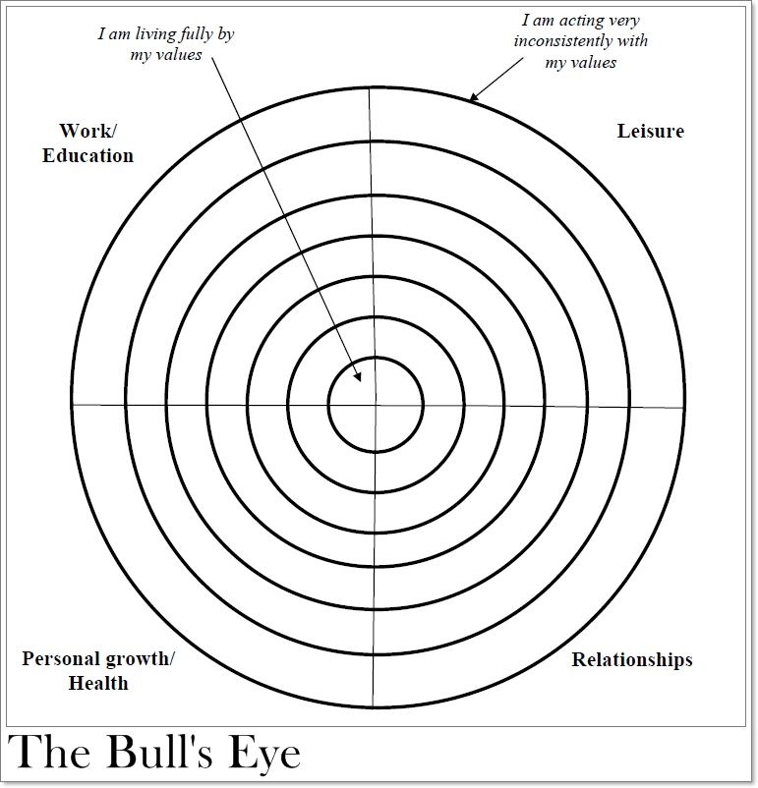

Work/Education – Write a few values in here
Personal Growth – Write a few values in here
Relationships – Write a few values in here
Leisure - Write a few values in here

Answer the following:

How does a discussion of values relate to our motivation for wanting to make change?

Might if affect our self-efficacy?

Might it affect whether we succeed or fail?

II. Mindset Exercise

For each of the following, classify them as applying to a growth or fixed mindset. Though the terms have not been defined yet, where do you think they logically fall?
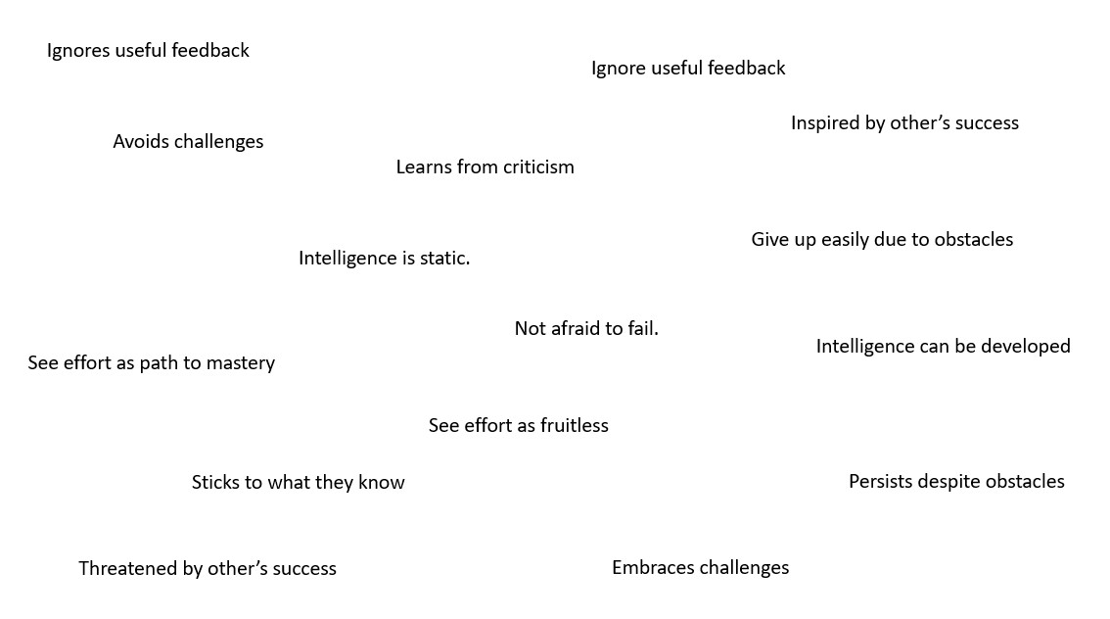

GROWTH MINDSET | FIXED MINDSET

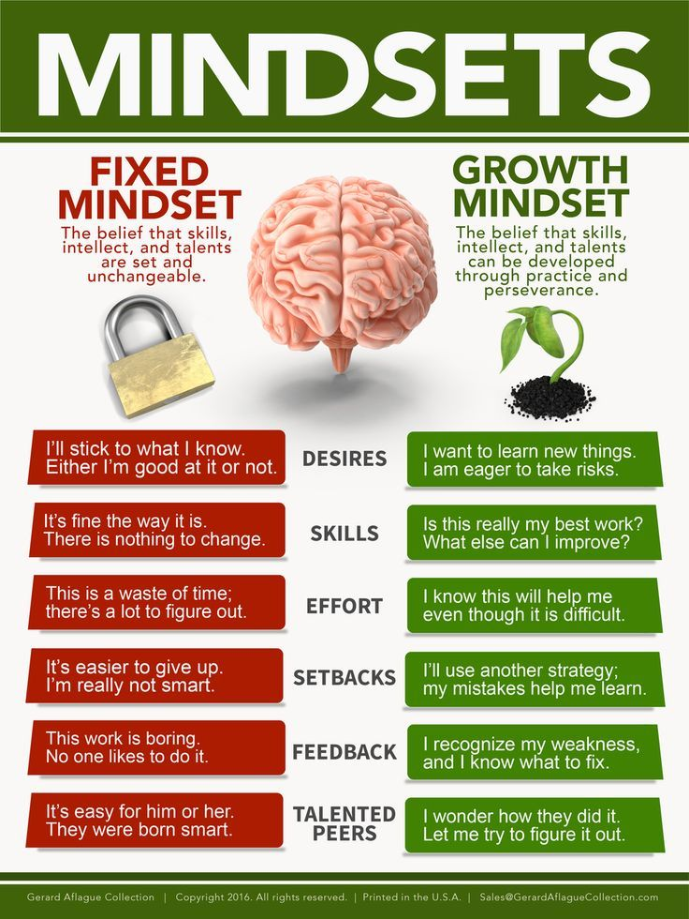

A growth mindset:
- Leads to a desire to learn
- Sees effort as key to improving ourselves
- And is driven by curiosity

A fixed mindset:
- Leads to a desire to look smart
- Says effort is not needed
- And is driven by the need to manage other’s impressions
And now consider this:

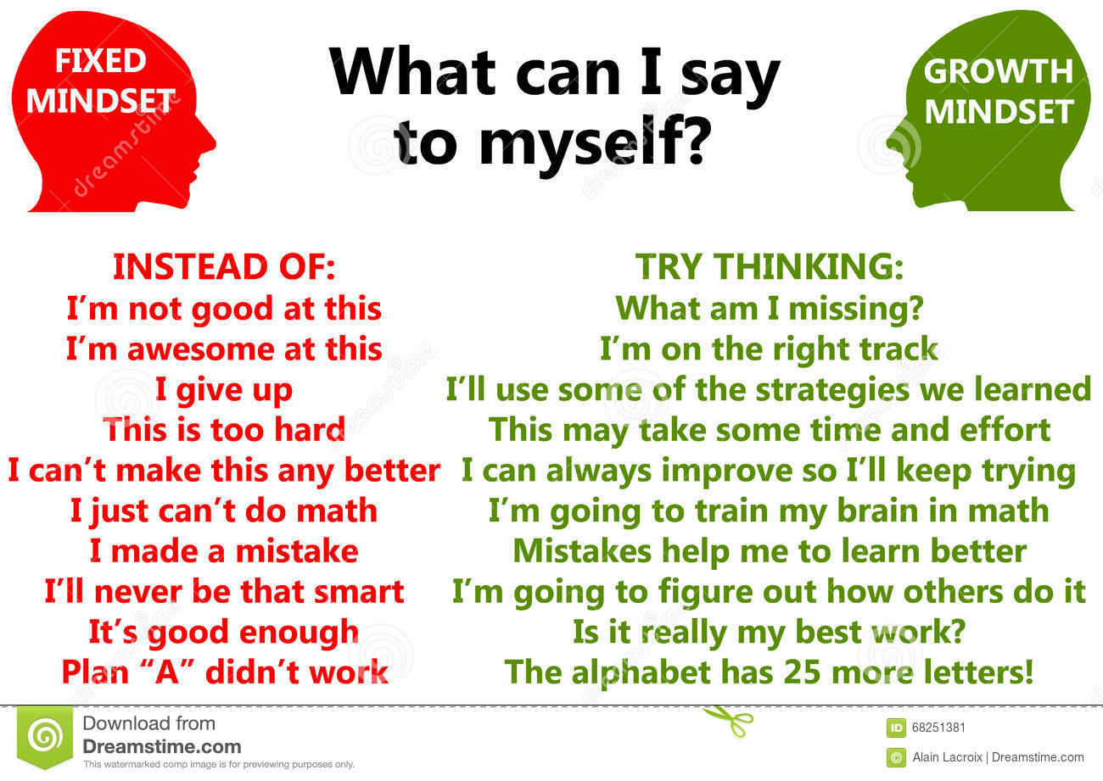

How do growth and fixed mindsets relate to self-efficacy and behavioral change?

III. Self-Reflection

Reflect on how what you learned about in this worksheet as it relates to values and the growth vs. fixed mindset can help you with your own behavior modification project.

